Title
Firstname A Lastname ¹, Firstname B Lastname ² and Firstname C Lastname ^{3,*}
¹ Department, Institute, City ZIP/Post Code, Country; email@email.com (F.A.L)
² Department, Institute, City ZIP/Post Code, Country; email@email.com (F.B.L)
³ Department, Institute, City ZIP/Post Code, Country; email@email.com (F.C.L)

* Correspondence: email@email.com

Article History  Received XX XXX 20XX  Revised XX XXX 20XX  Accepted XX XXX 20XX  Available Online XX XXX 20XX  Keywords:  Keyword 1  Keyword 2  Keyword 3  Keyword 4  Keyword 5 | Abstract  An abstract is a concise summary of a case report that provides readers with a quick overview of the essential information. The abstract should be written in a clear and concise manner, with a maximum word count of 300 words. It should provide a brief introduction to the case. The abstract should highlight the unique aspects of the case and any important learning points. In conclusion, a well-written abstract is an essential part of a case report, providing readers with a quick summary of the case and its significance.
 | Copyright: © 2024 by the authors. This is an open-access article distributed under the terms of the Creative Commons Attribution-NonCommercial 4.0 International License. (https://creativecommons.org/licenses/by-nc/4.0/)

1. Introduction
The introduction of a case report provides the reader with an overview of the patient and the reason for the report. The introduction should begin with a brief background of the patient's medical history and chief complaint. It should then explain the purpose of the report, such as the need to present a unique or rare case or to highlight a new treatment modality. The introduction should also include a concise statement of the case's significance, and why it is relevant to the medical community. Additionally, it may also be beneficial to briefly survey existing literature related to the case. This review can highlight any prior studies or insights that shed light on the current case, enhancing the reader's understanding of its uniqueness or the innovation it introduces. Overall, the introduction should be clear and engaging, giving readers a clear understanding of the patient and the purpose of the report.
2. Cases
Provides detailed information about the patient's medical history, physical examination, and diagnostic workup. This section should be well-organized and clearly written, providing readers with a comprehensive understanding of the case. It should include all relevant medical data, such as laboratory values, imaging results, and pathology reports. It may also be helpful to include photographs or diagrams to illustrate the case. The main body should be written in a logical sequence, detailing the patient's symptoms, examination findings, and the steps taken to reach a diagnosis.

2.1. Figures and Tables
All figures and tables should be cited in the main text in a consecutive order. Tables and figures must be centered. Large figures and tables may span both columns. Please ensure that tables are placed at the top or bottom of a page.
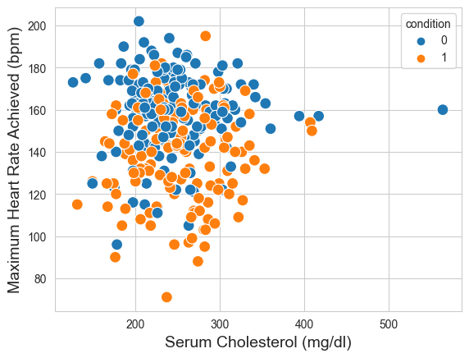
Figure 1. Example of a single figure caption.
Table 1. Example of a table caption.
Sample | Features
Sample 1 | 10
Sample 2 | 5
Sample 3 | 7
3. Discussions
The discussions section should provide an opportunity to interpret the case findings and discuss their significance. This section should begin with a restatement of the case's purpose and significance. It should then explore the implications of the case, such as any potential new treatment modalities or diagnostic techniques. It may also be helpful to discuss any limitations of the case or areas for future research. The discussion should be supported by evidence and references to the relevant literature.
4. Conclusions
The conclusions section should summarize the key findings of the report and their significance. It should also reiterate the purpose of the report and its potential impact on clinical practice. The conclusion should be clear and concise, leaving the reader with a clear understanding of the case and its implications. Finally, it may be appropriate to include any final thoughts or recommendations for future research.
Author Contributions: The following statements should be used “Conceptualization, X.X. and Y.Y.; methodology, X.X.; software, X.X.; validation, X.X., Y.Y. and Z.Z.; formal analysis, X.X.; investigation, X.X.; resources, X.X.; data curation, X.X.; writing—original draft preparation, X.X.; writing—review and editing, X.X.; visualization, X.X.; supervision, X.X.; project administration, X.X.; funding acquisition, Y.Y. All authors have read and agreed to the published version of the manuscript.”
Funding: The funding section should list any sources of funding for the study, including the grant number if applicable. If there is no funding, authors should state that “This study does not receive external funding.”
Ethical Clearance: Provide a clear statement indicating that ethical clearance was obtained for the study, including the name of the ethics committee or institutional review board (IRB) that granted clearance. Or add “Not applicable” for studies not involving humans or animals.
Informed Consent Statement: Any research article describing a study involving humans should contain this statement. Please add “Informed consent was obtained from all subjects involved in the study.” OR “Patient consent was waived due to REASON (please provide a detailed justification).” OR “Not applicable.” for studies not involving humans. You might also choose to exclude this statement if the study did not involve humans.
Written informed consent for publication must be obtained from participating patients who can be identified (including by the patients themselves). Please state “Written informed consent has been obtained from the patient(s) to publish this paper” if applicable.
Data Availability Statement: The data availability statement should state whether data is available and how it can be accessed. It should also provide any necessary details on data sharing policies.
Acknowledgments: This section should thank individuals or organizations that contributed to the study in any way, but did not qualify for authorship. This may include technical support, funding, or helpful discussions.
Conflicts of Interest: The section should disclose any potential or actual conflicts of interest that may have influenced the study design, interpretation of the results, or reporting of the findings. If there is no conflict of interest, authors should state that “All the authors declare that there are no conflicts of interest.”
References
References should be numbered in order of appearance in the text and listed at the end of the article. The list should include all sources cited in the article, including books, journal articles, and online sources. Each reference should be identified by a number in square brackets and listed in numerical order, for example, "according to the findings by Anderson [4]” and “as discussed extensively in related works [5,6]”. For example:
- Lastname, F. M., and Lastname, F. M. (Year). Journal Article Title. Journal Name, Vol. x, No. X, pp xx-xx, doi:xxxx
- Lastname, F. M. (Year). Proceeding Article Title. Conference Name. City, Vol. XX, pp XX-XX, doi:xxxx
- Lastname, F. M. (Year). Book Title. Publisher, City
- Lastname, F. M. (Year). Website Source Title. Retrieved from URL, accessed DD-MM-YYYY

