**Title**

**Firstname A Lastname 1, Firstname B Lastname 2 and Firstname C Lastname 3,\***

1 Department, Institute, City ZIP/Post Code, Country; [email@email.com](mailto:email@email.com) (F.A.L)

2 Department, Institute, City ZIP/Post Code, Country; [email@email.com](mailto:email@email.com) (F.B.L)

3 Department, Institute, City ZIP/Post Code, Country; [email@email.com](mailto:email@email.com) (F.C.L)

**\*** Correspondence: [email@email.com](mailto:email@email.com)

|  |  |
| --- | --- |
| **Article History**  Received XX XXX 20XX  Revised XX XXX 20XX  Accepted XX XXX 20XX  Available Online XX XXX 20XX  **Keywords**:  Keyword 1  Keyword 2  Keyword 3  Keyword 4  Keyword 5 | **Abstract**  A single paragraph of about 300 words maximum. The abstract should briefly state the problem, the purpose/aim of the research, the main methodology, the results, and the significant conclusion. Because an abstract is frequently given apart from the article, it must be able to stand on its own. As a result, references/citations should be avoided. Non-standard or rare abbreviations should also be avoided, but, if necessary, they must be specified in the abstract itself. |
|  | Copyright: © 2024 by the authors. This is an open-access article distributed under the terms of the Creative Commons Attribution-NonCommercial 4.0 International License. [(https://creativecommons.org/licenses/by-nc/4.0/)](https://creativecommons.org/licenses/by-nc/4.0/) |

**1. Introduction**

The Introduction presents the purpose of the studies reported and their relationship to earlier work in the field. It should not be an extensive review of the literature. Use only those references required to provide the most salient background to allow the readers to understand and evaluate the purpose and results of the present study without referring to previous publications on the topic.

**2. Materials and Methods**

The Materials and Methods sections should be brief, but they should provide enough technical details so that someone with expertise can replicate the experiments. If you've developed new methods for your study, those should be explained thoroughly. When it comes to techniques that have been previously published by other researchers, you don't need to explain them extensively in your paper. Instead, you can simply mention the name of the method and cite the source where it was originally described. This helps ensure that the paper doesn't become too lengthy while still providing the necessary information for others to recreate your experiments.

**3. Results and Discussion**

This section should present the findings of the study. It should be organized in a logical manner and use tables and figures to help illustrate the results. The results should be presented clearly and accurately, with appropriate statistical analyses. This section should also interpret the results and explain how they answer the research question(s) or support the hypothesis(es). It should compare the results with previous studies and discuss the implications of the findings. It should also identify any limitations of the study and suggest areas for future research. This section may be divided by subheadings. It should provide a concise and precise description of the experimental results, their interpretation, as well as the experimental conclusions that can be drawn.

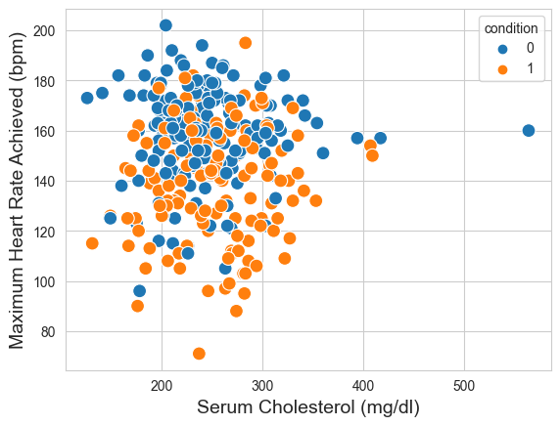

**Figure 1.** Example of a single figure caption.

**Table 1.** Example of a table caption.

|  |  |
| --- | --- |
| **Sample** | **Features** |
| Sample 1 | 10 |
| Sample 2 | 5 |
| Sample 3 | 7 |

*3.1. Figures and Tables*

All figures and tables should be cited in the main text in a consecutive order. Tables and figures must be centered. Large figures and tables may span both columns. Please ensure that tables are placed at the top or bottom of a page.

*3.2. Mathematical Equations*

Example of an equation:

|  |  |
| --- | --- |
|  | (1) |

The text following an equation need not be a new paragraph. Equations should be punctuated in the same way as regular text.

**4. Conclusions**

The conclusions section should summarize the main findings and their implications. It should restate the research question(s) or hypothesis(es) and state whether they were supported or not. It should also discuss the significance of the findings for the field.

**Author Contributions:** The following statements should be used “Conceptualization, X.X. and Y.Y.; methodology, X.X.; software, X.X.; validation, X.X., Y.Y. and Z.Z.; formal analysis, X.X.; investigation, X.X.; resources, X.X.; data curation, X.X.; writing—original draft preparation, X.X.; writing—review and editing, X.X.; visualization, X.X.; supervision, X.X.; project administration, X.X.; funding acquisition, Y.Y. All authors have read and agreed to the published version of the manuscript.”

**Funding:** The funding section should list any sources of funding for the study, including the grant number if applicable. If there is no funding, authors should state that “This study does not receive external funding.”

**Ethical Clearance:** Provide a clear statement indicating that ethical clearance was obtained for the study, including the name of the ethics committee or institutional review board (IRB) that granted clearance. Or add “Not applicable” for studies not involving humans or animals.

**Informed Consent Statement:** Any research article describing a study involving humans should contain this statement. Please add “Informed consent was obtained from all subjects involved in the study.” OR “Patient consent was waived due to REASON (please provide a detailed justification).” OR “Not applicable.” for studies not involving humans. You might also choose to exclude this statement if the study did not involve humans.

Written informed consent for publication must be obtained from participating patients who can be identified (including by the patients themselves). Please state “Written informed consent has been obtained from the patient(s) to publish this paper” if applicable.

**Data Availability Statement:** The data availability statement should state whether data is available and how it can be accessed. It should also provide any necessary details on data sharing policies.

**Acknowledgments:** This section should thank individuals or organizations that contributed to the study in any way, but did not qualify for authorship. This may include technical support, funding, or helpful discussions.

**Conflicts of Interest:** The section should disclose any potential or actual conflicts of interest that may have influenced the study design, interpretation of the results, or reporting of the findings. If there is no conflict of interest, authors should state that “All the authors declare that there are no conflicts of interest.”

**References**

References should be numbered in order of appearance in the text and listed at the end of the article. The list should include all sources cited in the article, including books, journal articles, and online sources. Each reference should be identified by a number in square brackets and listed in numerical order, for example, "according to the findings by Anderson [4]” and “as discussed extensively in related works [5,6]”. For example:

1. Lastname, F. M., and Lastname, F. M. (Year). Journal Article Title. Journal Name, Vol. x, No. X, pp xx-xx, doi:xxxx
2. Lastname, F. M. (Year). Proceeding Article Title. Conference Name. City, Vol. XX, pp XX-XX, doi:xxxx
3. Lastname, F. M. (Year). Book Title. Publisher, City
4. Lastname, F. M. (Year). Website Source Title. Retrieved from URL, accessed DD-MM-YYYY